# Roll no: 73772121158

# Email: mahizha.mk1474@gmail.com

1. **Create a local git repo with the name "MyRepo**".

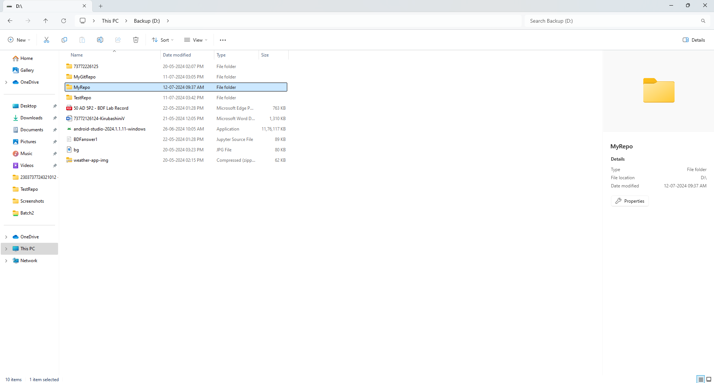

1. **Create one .txt file, five .c files and five .java files in the working area.**

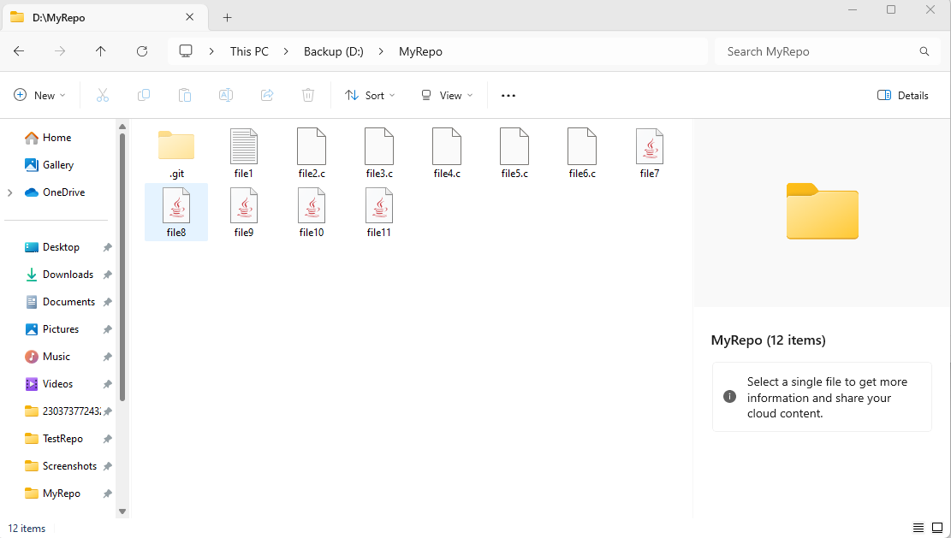

1. **Verify the git status**

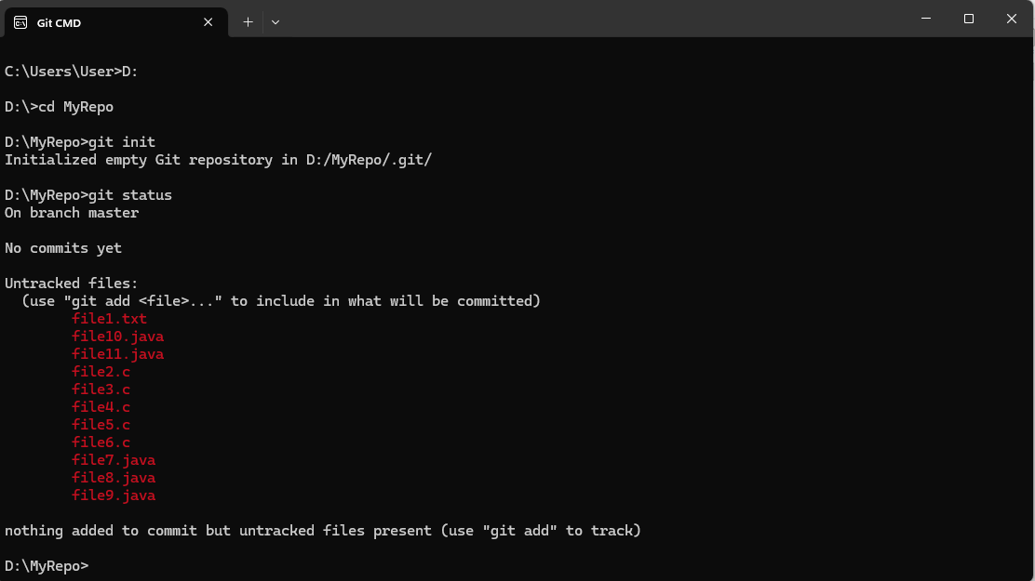

1. **Add only the .txt into the staging area**

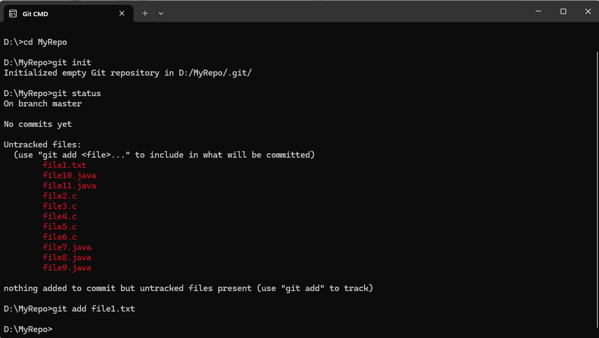

1. **Verify the git status**

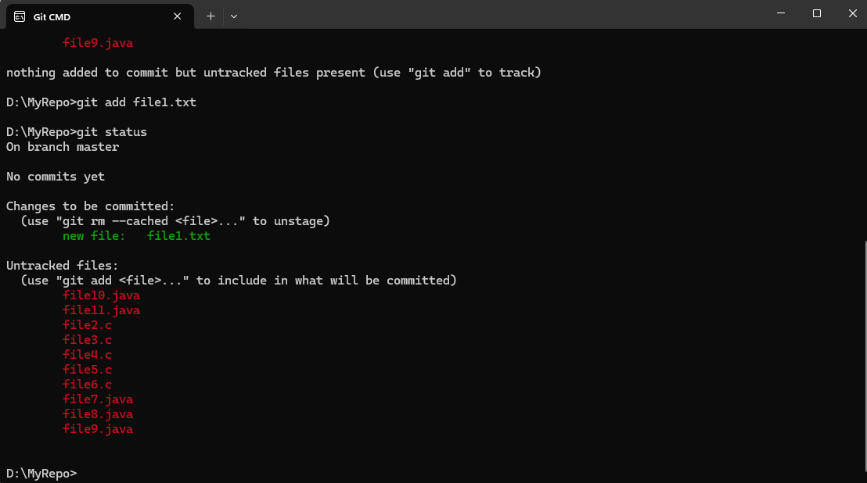

1. **Make a commit with the name "TXT Commit"**

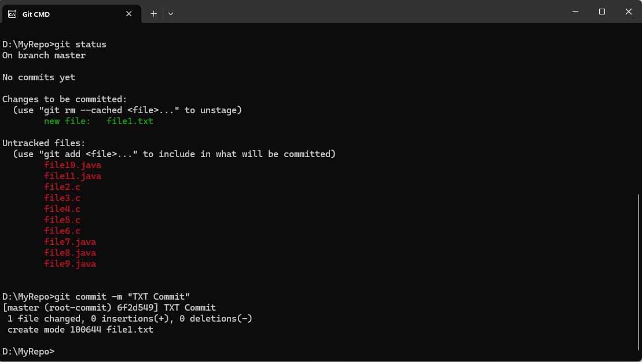

1. **Add all .c files into the staging area**

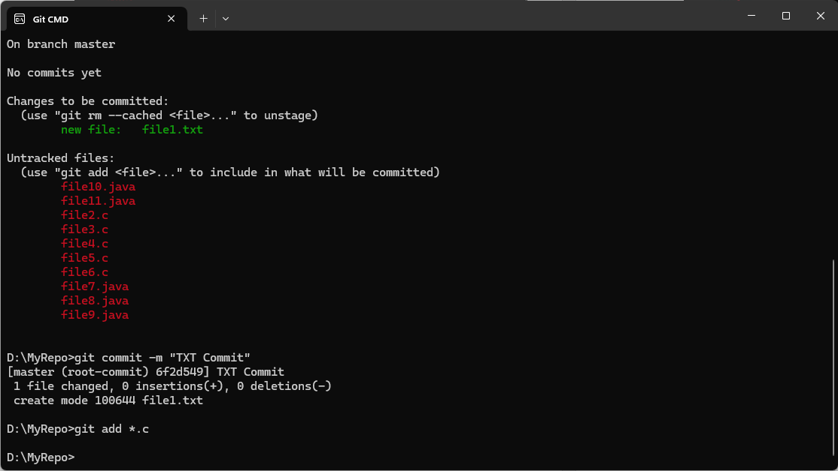

1. **Verify the git status**

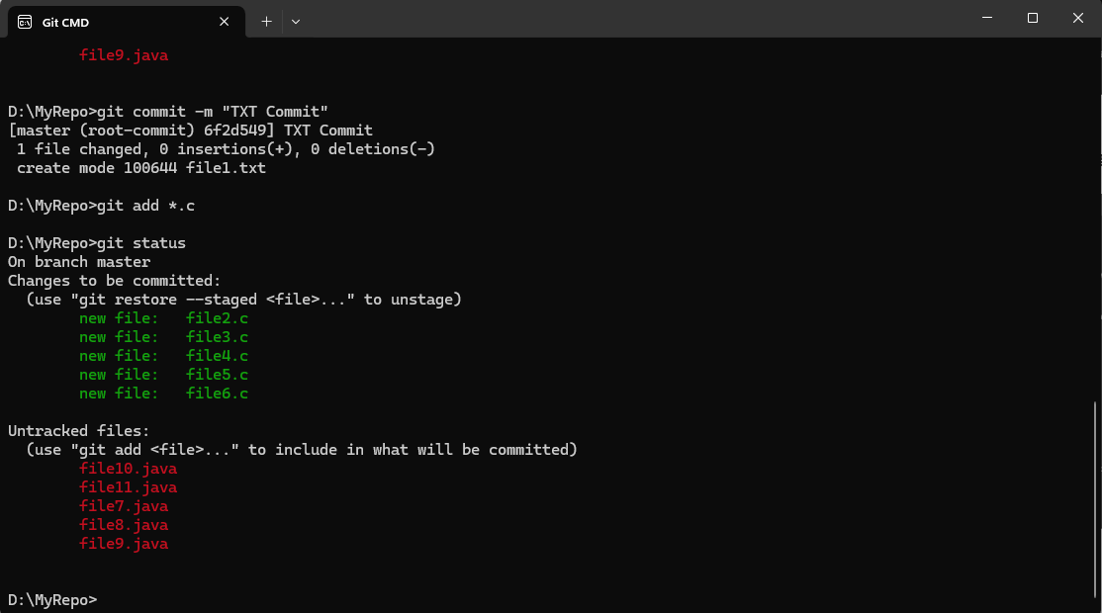

1. **Make a commit with the name "C Commit"**

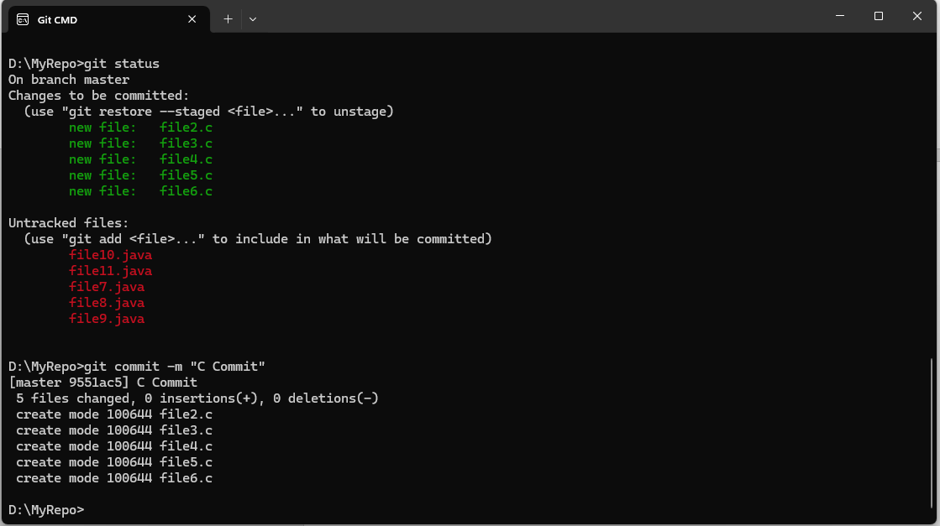

**10. Add all .java files into the staging area**

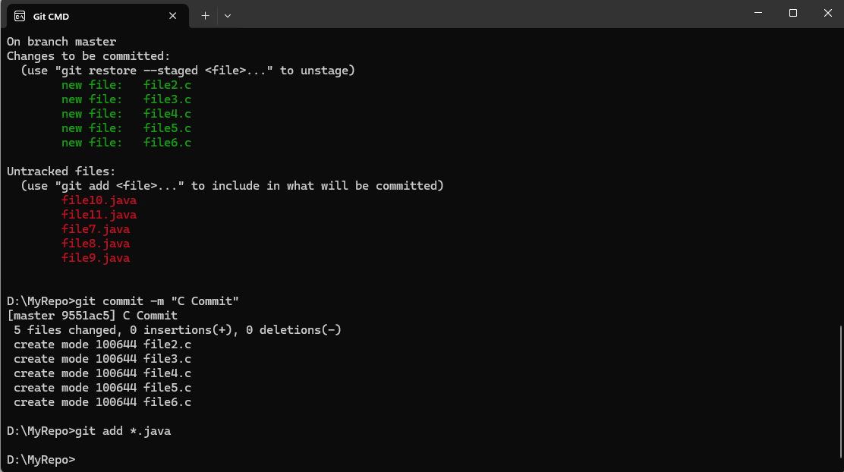

1. **Verify the git status**

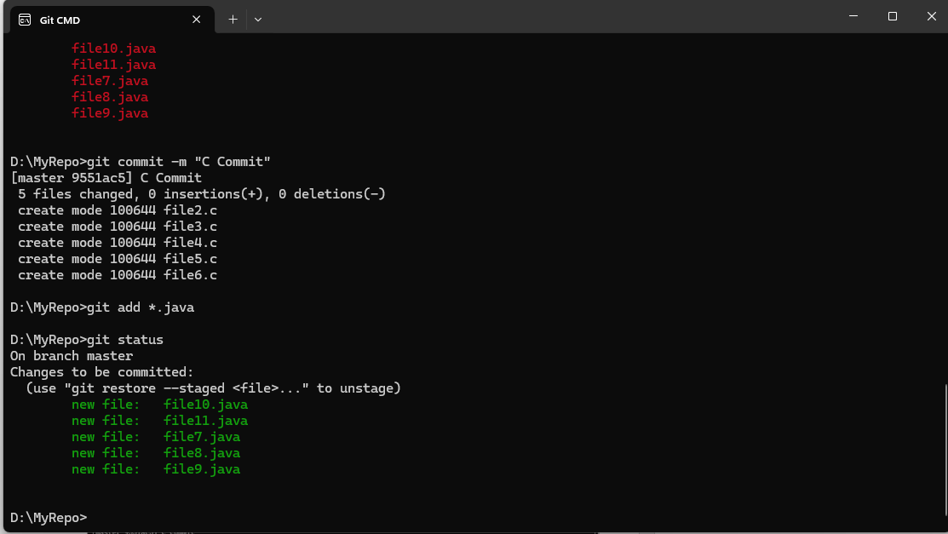

1. **Make a commit with the name "Java Commit**

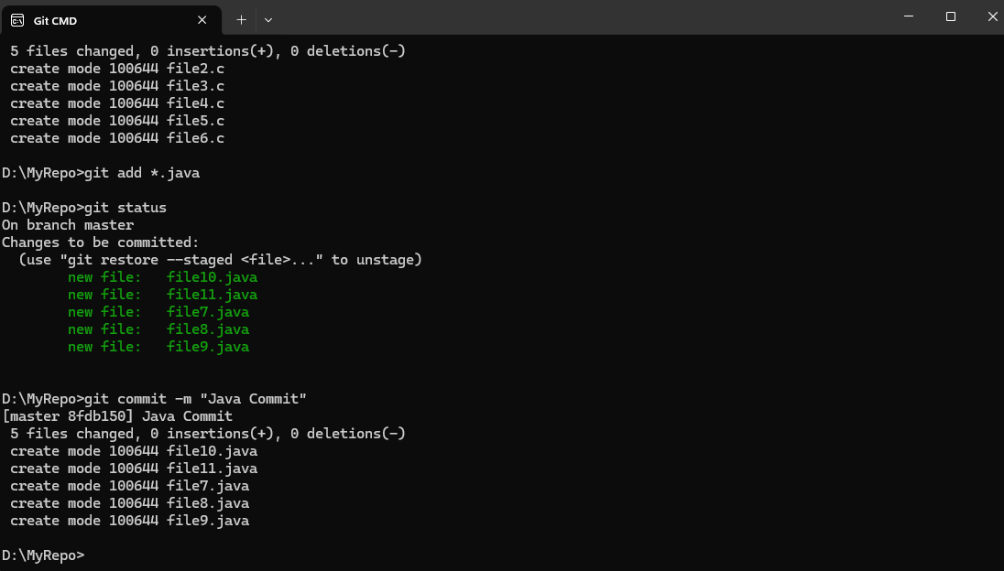

**13. Delete all .java files from working area**

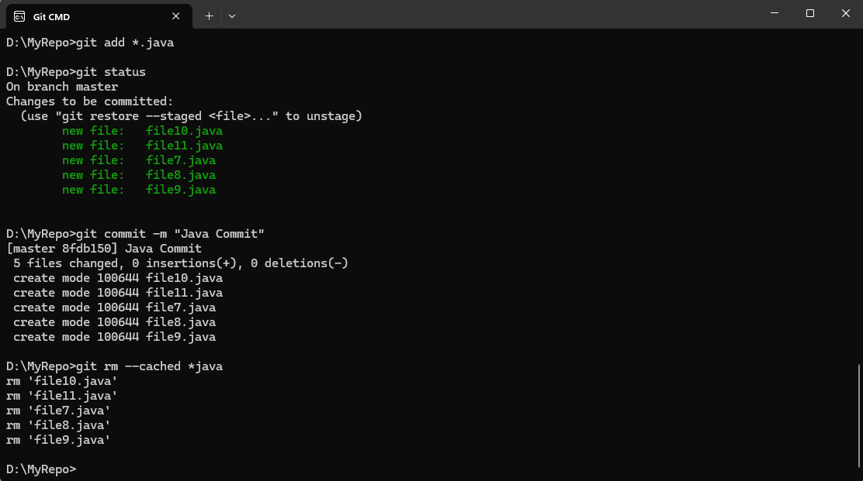

**14. Now see the status**

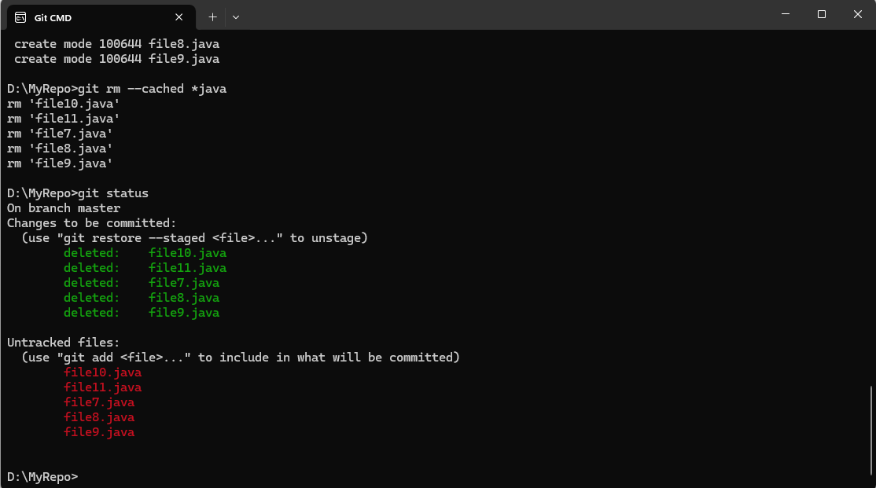

**15. Add the changes into the staging area**

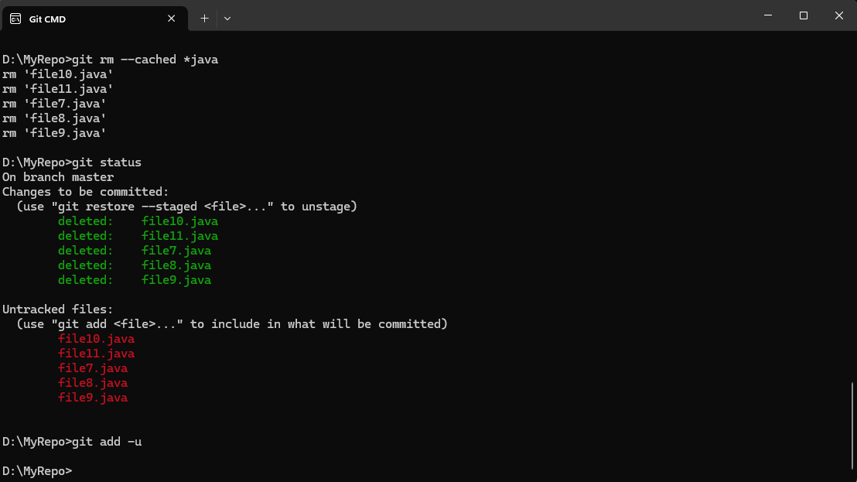

**16. Make a commit with the name "Delete Java Commit"**

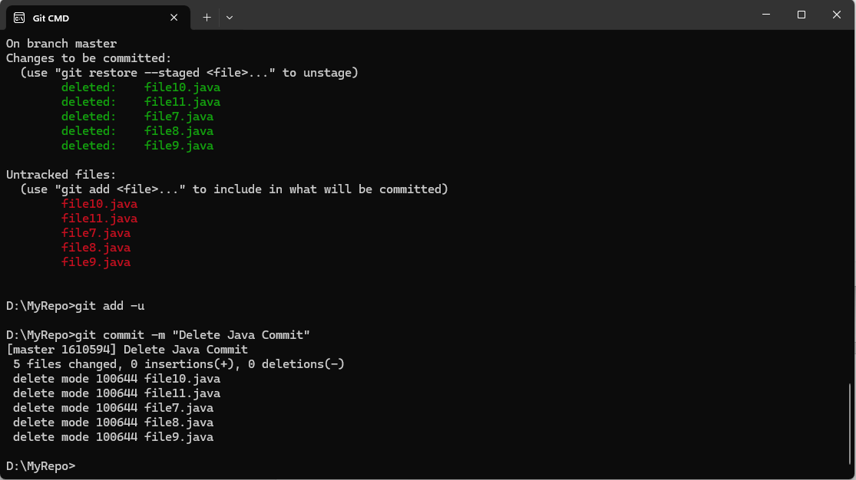

**17. Display all commit details**

